Support Vector Machine
- It’s one of widely used, supervised learning algorithm for classification and regression tasks
- It handles both linear and non-linear data
- It look for to find the best boundary known as hyperplane that separates different classes in the data
- Example: spam vs not spam , cat vs dog
- The major goal – to maximize margin between two classes
  - The larger margin – model performs well on unseen data

https://www.appliedaicourse.com/blog/support-vector-machine-algorithm/

in 2D, this hyperplane is a line
in 3D, it’s plane
in higher dimensions, it’s a hyper plane

distance between hyperplane and the nearest points from each class (called support vectors)

SVM
- Works well even when no.of features > no.of samples
- Focuses only on support vectors, ignoring irrelevant data
- It can model linear and non-linear patterns using kernels
- It does strong generalization

SVM Kernels
Kernels transform the input data into a higher dimensional space to make it easier to separate classes
Linear Kernel
- Used when data is linearly separable

function
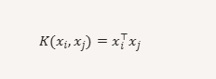

Pros
Simple and fast
Works well with large feature sets
Cons
Fails with non-linear data

Polynomial Kernel
Used when data has non-linear relationships but still follows a structured pattern
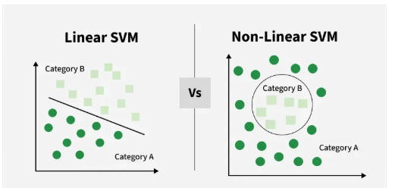

Function
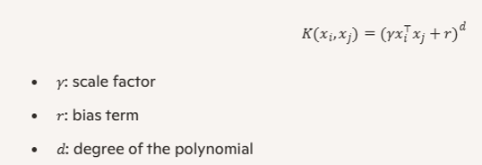

Captures curved boundaries
Degree controls the complexity

Ex
Classifying handwritten digits with curved strokes

Pros
Models interactions between features
Flexible for structured non-linear data

Cons
Sensitive to parameter tuning
Slower than linear kernel

RBF radial basis function kernel
Used when data is highly non-linear and complex

Function
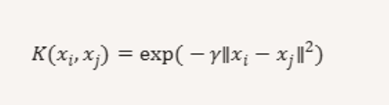

- Maps data into infinite dimensional space
- Can model very complex boundaries
Ex
Image classification, biometrics, …

Pros
- Flexible
- Handles non-linear patterns well
Cons
- Harder to interpet
- Requires careful tuning

Overall
Linear linearly separable data straight line fast
Polynomial structured non-linear data curved moderate
RBF complex, non linear data highly flexible slower

Assignment
Additional reading of SVM and someone to provide a lecture in the class (mandatory) - I need a date

Q does high accuracy always mean a better model?
NO – model selection depends on context, interpretability, scalability and business constraints, metrics…

Pros

Logistic regression
It’s a go to model in many industries
- Probability scores – outputs interpretable probabilities,
- Efficient implementation –
- Regularization – helps to manage multicolinearity
- Widely used in finance, healthcare, marketing

Decision Trees
- Flexible
- Easy to visualize
- Easy to explain with decision rules
- Non-linear data handling – can model complex relationships
- Feature interaction – captures interactions between variables naturally
Ex – retail, a tree might split customers by time of purchase and cart behavior to predict gender – easy for marketing teams to understand

SVM’s
High dimensional and complex spaces
Effective even when no.of featrues > no.of samples
Non-linear interaction – kernels allow modeling of complex boundaries
Selective transformation – focuses on support vectors, not entire data

Ex – in image classification, SVMs can separate classes using pixel-level features with RBF kernels..

Cons
Logistic Regression
It has limitations
- Poor in high dimensions: struggles when feature space is large
- Categorical overload doesn’t handle many categorical variables
- Linear assumption – non-linear features must be transformed
- Data sensitivity – small changes can shift the model significantly

Decision trees
- Overfitting – easily memorizes training data, especially with deep trees
- No probability scores: outputs class labels, not confidence levels

SVM –
- SVMs are powerful but it demands
  - Computational cost – training time increases with dataset size
  - Kernel selection – choosing with right kernel requires trial and error

Certain recommendation for end to end modeling
- Start with logistic regression
  - Its baseline model
  - It helps identify important features through coefficient analysis

- Try decision tress
  - Build a DT and compare its performance with Logistic regression

Use SVM
- If neither logistic regression nor Decision trees meet your performance goals, try support vector machines

Decision Trees
2 types
- CART – classification and regression trees
- CHAID – chi-square automatic interaction detection

CART
- It builds binary trees – each node splits into two branches
- It uses Gini index (for classification) to decide splits
- It uses MSE (for regression) to decide splits
- It is ideal for prediction tasks – it focuses on accuracy and performance
- Use if target is continuous or binary
- Use when building a model for deployment
Ex
Predicting whether a customer will churn based on usage patterns and demographics
Pros
- Works for both classification and regression
- Easy to implement and tune
- Good predictive performance
Cons
- Trees can become deep and complex
- Harder to interpret when many splits exist

CHAID
- It builds non-binary trees – nodes can split into multiple branches
- It uses chi-square tests to evaluate relationships between independent variables and the target
- It is ideal for driver analysis – understanding which features influence outcomes
- Use to understand feature impact
- When data is mostly categorical

Pros
- Easier to interpret
- Highlights key drivers of outcomes
- Great for categorical data

Cons
- NOT SUITABLE FOR REGRESSION TASKS
- Less accurate for prediction compared to CART

Ex – analyzing which factors (ex training intensity, player experience, match location etc.,) influence the indian cricket team’s win/loss record
(Assignment – download the available cricket data set from kaggle and use chi-square test, analyze the above factors)

If your goal is to predict whether the team will win a tournament use CART
If the goal is to understand what factors influence winning CHAID

